17. ReactJS-HOL

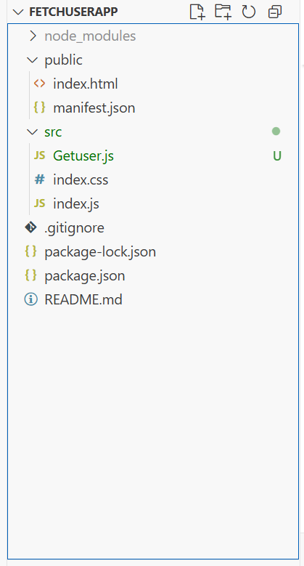

Getuser.js
import React, { Component } from 'react';

class Getuser extends Component {
constructor(props) {
super(props);
this.state = {
person: null,
loading: true
};
}

async componentDidMount() {
const url = "https://api.randomuser.me/";
const response = await fetch(url);
const data = await response.json();
this.setState({ person: data.results[0], loading: false });
console.log(data.results[0]);
}

render() {
const { person, loading } = this.state;

if (loading) {
return <h2>Loading...</h2>;
}

return (
<div style={{ textAlign: 'center', marginTop: '50px' }}>
<h2>
{person.name.title} {person.name.first} {person.name.last}
</h2>
<img src={person.picture.large} alt="user" />
</div>
);
}
}

export default Getuser;

App.js
import React from 'react';
import Getuser from './Getuser';

function App() {
return (
<div className="App">
<Getuser />
</div>
);
}

export default App;

